Kochi Branch Page - Content

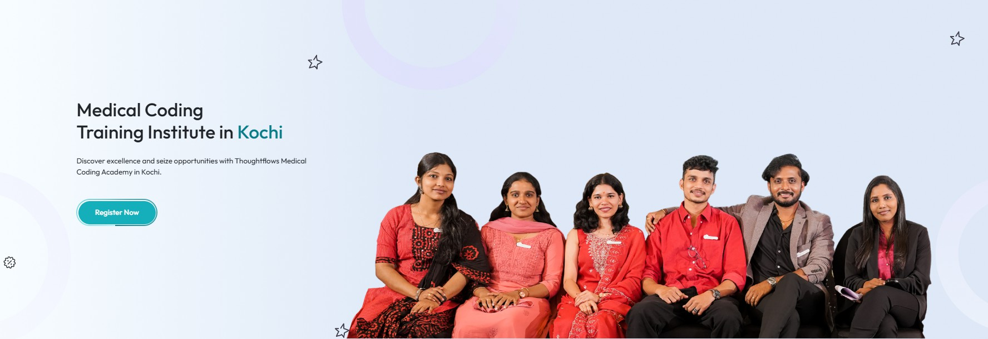

Banner Content

1.Medical Coding Course in Kochi with Placement Support

Learn Medical Coding through Practical Training, CPC Certification Guidance, and Placement Support for Freshers, Professionals, and Career Switchers.

- CTA Button: Book Free Demo Class

- Need to change image - Employee image instead of Students image

Why Medical Coding is Gaining Popularity Among Students and Professionals in Kochi
Kochi is one of Kerala's major healthcare and business hubs, with growing opportunities in healthcare support services and revenue cycle management. As awareness of healthcare careers continues to increase, many graduates and professionals in Kochi are exploring Medical Coding as a career path that combines healthcare knowledge with professional growth opportunities.
—

Why Medical Coding is Becoming a Preferred Career Choice
Medical Coding plays an important role in the healthcare ecosystem by transforming medical diagnoses, treatments, and procedures into standardized codes used for documentation and reimbursement processes.
Many graduates choose Medical Coding because it offers:

- A professional healthcare career pathway
- Opportunities for freshers and experienced professionals
- Continuous learning and career growth
- Industry-recognized certification options
- Opportunities within healthcare and revenue cycle management sectors

For students and professionals seeking a healthcare-focused career without direct patient care responsibilities, Medical Coding offers a promising career direction.

Medical Coding Training in Kochi for Graduates, Professionals & Career Switchers
Whether you are a recent graduate exploring healthcare career opportunities, a working professional considering a career transition, or someone planning to restart your professional journey after a break, Medical Coding can provide a structured pathway into the healthcare industry.
Our Medical Coding Training in Kochi is designed to help learners understand industry practices through a step-by-step learning approach. Students gain exposure to medical terminology, anatomy, coding concepts, healthcare documentation standards, and coding guidelines while developing practical knowledge relevant to professional environments.
The training is suitable for both beginners and individuals who wish to strengthen their existing healthcare knowledge.

Who Can Join Our Medical Coding Training?
Medical Coding is suitable for graduates, professionals, and individuals looking to build a career in the healthcare industry.

Our programs are commonly chosen by:

- Life Science Graduates
- Nursing Graduates
- Pharmacy Graduates
- Biotechnology Graduates
- Microbiology Graduates
- Allied Health Science Graduates
- Healthcare Professionals
- Fresh Graduates
- Career Switchers
- Professionals Looking for New Career Opportunities

Students from non-life science backgrounds may also explore Medical Coding opportunities based on their learning ability, career goals, and program requirements.
No prior Medical Coding experience is required to begin learning.

Your Medical Coding Learning Journey
- Attend Free Career Guidance Session
- Enroll in the Training Program
- Learn Medical Coding Fundamentals
- Practice Real Coding Scenarios
- Prepare for CPC Certification
- Attend Interview Preparation Sessions
- Access Placement Support

Industry-Oriented Training Designed Around Real Healthcare Processes
At ThoughtFlows, training goes beyond theoretical concepts. Our programs are designed to help learners understand how Medical Coding functions within real healthcare workflows.
Depending on the chosen program, students may learn:

  - Medical Terminology
  - Human Anatomy and Physiology
  - Disease Processes

  - Healthcare Documentation
  - ICD Coding Concepts
  - CPT Coding Concepts
  - Coding Guidelines
  - Reimbursement Concepts
  - Certification Preparation
  - Practical Coding Exercises

The objective is to help learners build strong foundational knowledge while understanding the practical expectations of the healthcare industry.

CPC Certification Guidance
Professional certification is an important milestone for many aspiring Medical Coders.

Our CPC certification guidance is designed to help students prepare effectively through structured learning, coding practice sessions, mock assessments, exam preparation support, and mentor guidance.
Certification preparation helps learners strengthen their coding knowledge and improve their confidence as they pursue career opportunities in the Medical Coding field.

Placement Support to Help You Start Your Career
For many students, enrolling in a Medical Coding course is ultimately about building a successful career.
Along with training, ThoughtFlows provides placement support designed to help students prepare for employment opportunities within the healthcare industry.
Our support includes:

  - Resume Preparation Guidance
  - Interview Readiness Sessions
  - Industry Awareness Training
  - Communication Skill Development
  - Career Guidance Support
  - Recruitment Opportunity Updates

Our goal is to help students become professionally prepared and confident when pursuing career opportunities.

Why ThoughtFlows is Considered Among the Best Medical Coding Institutes in Kerala
Students searching for the best Medical Coding institute in Kerala often compare factors such as training quality, certification guidance, practical learning opportunities, trainer expertise, and career support before making their decision.
At ThoughtFlows, we focus on helping students build strong Medical Coding knowledge through structured learning, practical exposure, CPC certification guidance, and placement-focused support. Our goal is not just to provide training, but to help learners develop the skills and confidence needed for long-term career growth in the healthcare industry.

Medical Coding Training in Kerala for Aspiring Healthcare Professionals
ThoughtFlows provides Medical Coding training in Kerala for students, graduates, healthcare professionals, and career switchers looking to build a future in the healthcare industry. Students from Kochi, Ernakulam, Thrissur, Calicut, Trivandrum, Kottayam, Palakkad, Kannur, and other regions across Kerala choose our programs for their practical learning approach, certification guidance, and career-focused support.

Frequently Asked Questions

How much are Medical Coding course fees in Kerala?

Medical Coding course fees in Kerala generally range between ₹23,000 and ₹45,000, depending on factors such as course duration, training format, certification guidance, and additional support services. Students should evaluate the overall quality of training, practical learning opportunities, and career support before making a decision.

Is Medical Coding suitable for freshers?
Yes. Many students begin their Medical Coding journey as freshers. Training programs are designed to help learners understand concepts from the fundamentals before progressing to advanced topics.

Can working professionals switch to Medical Coding?
Yes. Many professionals choose Medical Coding as a healthcare-focused career transition option. Proper training and skill development can help individuals build the knowledge required for the field.

I have a career gap. Can I still learn Medical Coding?
Yes. Many learners join Medical Coding training after a career break. Learning commitment, practical knowledge, communication skills, and interview preparation play an important role in career development.

Can non-life science graduates learn Medical Coding?
Yes, absolutely. Non-life science graduates can also learn Medical Coding. Basic medical concepts, anatomy, physiology, and coding guidelines are taught during the training, making it possible for candidates from any educational background to build a successful career in Medical Coding. With proper training and CPC certification, they can access excellent job opportunities in India as well as abroad.

What should I look for when choosing a Medical Coding institute in Kerala?
Students should evaluate curriculum quality, practical learning opportunities, certification guidance, trainer expertise, student support, placement assistance, and overall career development opportunities before making a decision.

How do I choose the best Medical Coding training institute in Kochi?
Look for an institute that provides structured training, practical learning, certification guidance, placement support, experienced trainers, and a strong focus on student career development.

Is Medical Coding available through online training in Kerala?
Yes, Medical Coding training is available through online mode in Kerala. We provide live interactive sessions, allowing students to learn from anywhere with the guidance of experienced trainers. Online classes offer the same quality of training, doubt-clearing support, and placement assistance, making it convenient for both students and working professionals.

